Creating a macro to print in PowerPoint:
Go to the following site http://support.microsoft.com/kb/166859 and take a print screen of copying the code to use as your evidence for collecting the macro code. Then go to page 2 of this document to see the edited code we are going to use as it has been optimised for use within Brooke Weston.
Note: We are not going to use this code as the code given on page 2 works more effectively.
Example:
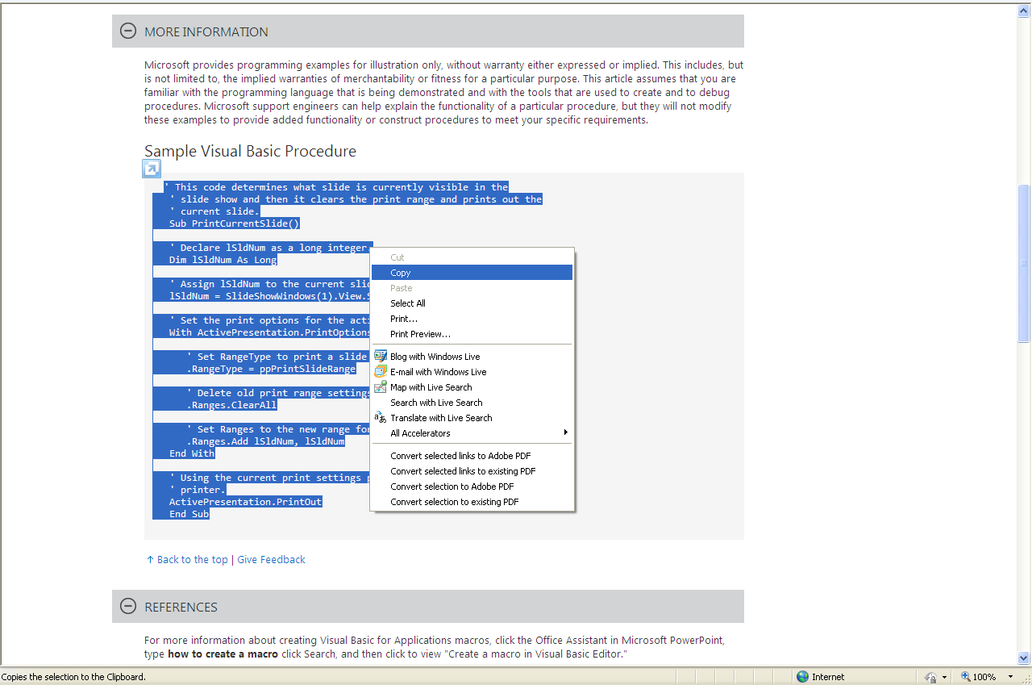

Now copy the code below to use as it has a line to make it work with Brooke Weston’s printers!
' This code determines what slide is currently visible in the
' slide show and then it clears the print range and prints out the
' current slide.
Sub PrintCurrentSlide()

' Declare lSldNum as a long integer.
Dim lSldNum As Long

' Assign lSldNum to the current slide number.
lSldNum = SlideShowWindows(1).View.Slide.SlideNumber

' Set the print options for the active presentation.
With ActivePresentation.PrintOptions

' Select the printer
.ActivePrinter = "\\BWPRINT\BernersLee"

' Set RangeType to print a slide range.
.RangeType = ppPrintSlideRange

' Delete old print range settings.
.Ranges.ClearAll

' Set Ranges to the new range for the current slide.
.Ranges.Add lSldNum, lSldNum
End With

' Using the current print settings print the slide to the default
' printer.
ActivePresentation.PrintOut

End Sub

